Student Self-Registration for Poll Everywhere

Having your student register for your Poll Everywhere course will allow you to keep up with their responses and activity.

You will have your students create and register their own accounts. To do this, follow the directions below:

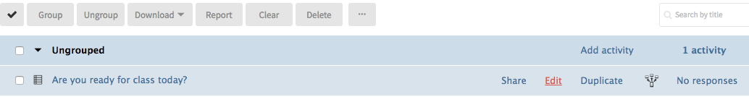
- Log in to Poll Everywhere and create a new poll with a basic start of class question (ex. Are you ready for class today?).
- Once your poll is created, click the check-box next to it and click Group
- Create a New Group called “Student Registration”
- Click the check-box next to the “Student Registration” group and at the top click the “…” and then Edit
- On the next screen, under “Who Can Respond” area choose “Only registered participants” then click the red “Apply” button and click “Permanently Modify Polls”
- Your students must now register before they can answer this question.

When students try to answer the Poll question, they will receive the text below, which states “Only registered users can respond to this poll.” They must click the link provided, which takes them to a page where they must register.
(Registration takes only takes a few seconds)

