**Adding Your Microsoft 365 Email to the Outlook App (Android & iOS)**

This guide walks you through setting up Outlook on both Android and iOS devices.

**Step 1: Install Outlook App on your phone**

1. Open the App store (iPhone) or Google Play Store (Android)
2. Search for **Microsoft Outlook**

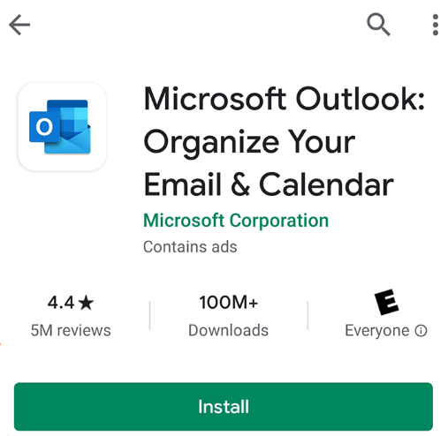

1. Tap **Install** or **GET**

(Depending on your device)

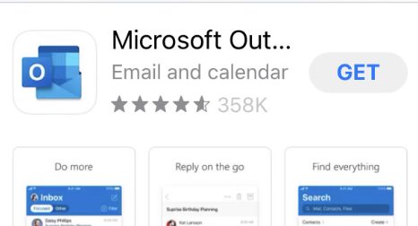

**Step 2: Add your account**

1. Open the Outlook app on your phone

2. Press **Get Started** (If this is the first time you have used the app)

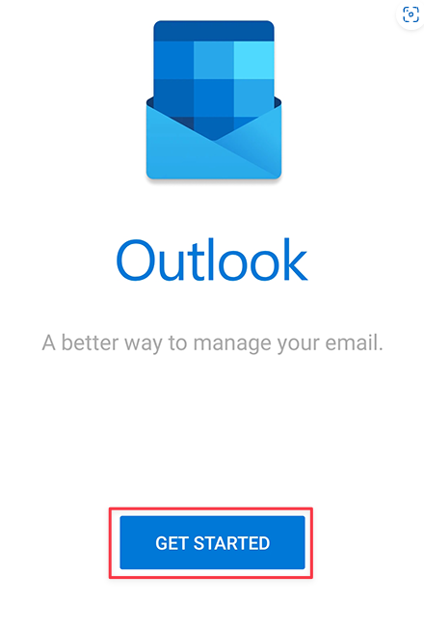

3. On the following screen, press **Add Account**

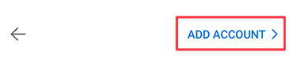

4. Enter your email address and press **Add Account**

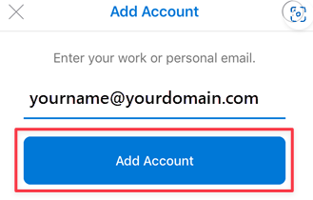

**emailaddress@longwood.edu**

1. If Outlook detects your account, move ahead to steps 6 and 7 to enter your password and complete multi-factor authentication.
2. If Outlook does not detect your account, select Microsoft 365/Office 365 as your email provider.

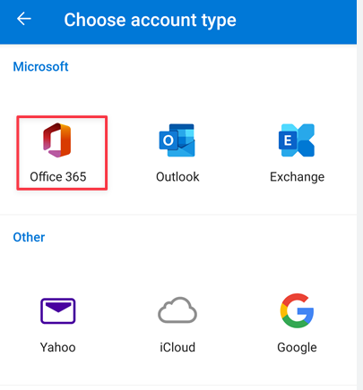

6. Enter your password and press **Sign In**

7. Complete multi-factor authentication

8. You're done!

Email and calendars will begin syncing.