Longwood University
Area Coordinator’s Manual

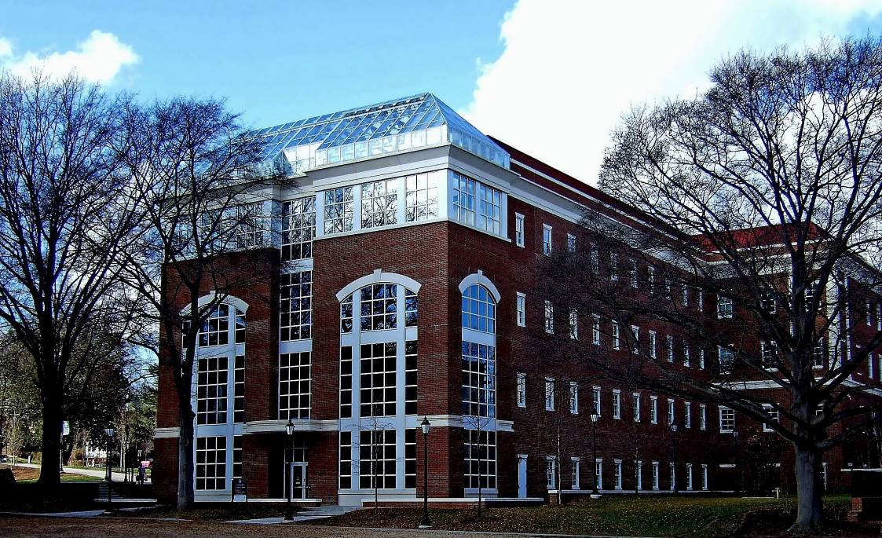

Building For The Future
Through Better Communication

Contents
I. Program Operation & Benefits 3
II. Area Coordinator Program Administration 4
a. Coordinator Designation 4
b. Coordination and Communication Meetings 4
III. Area Coordinator Duties & Expectations 5
a. General Management 5
c. Health and Safety 6
d. Utility Shutdowns 6
e. Area Renovations and Remodeling 6
g. Workorders 7
h. Training 7

Program Operation & Benefits
Purpose

The diversity of University programs and activities frequently requires coordination of building operations by various departments. Building coordination often involves the services provided by support units such as the Facilities Management Department, University Police, the Environmental Health and Safety Department, and Information Technology Services. Building coordination is most efficiently accomplished through the careful selection and assignment of Area Coordinators. The Area Coordinator is the first line of communication for interaction between the various divisions of the University and the building’s occupants.

This manual is intended to clarify the role of the Area Coordinator and provide information that will assist in the performance of these essential duties.

Benefits

- Better understanding through improved communication between service organizations and building occupants.
- Quicker workorder turn around with less disruption to building functions.
- Improved scheduling and planning of area work, projects, or training.
- Improved problem solving by participation of area occupants.
- Improved life safety procedures through better informed employees.
- Central point of contact for feedback on work request.
- Ability to prioritize workorders through better communication.

Area Coordinator Program Administration

Coordinator Designation
The Area Coordinator Program is managed by the Facilities Management Department. The Area Coordinator (AC) shall be a full-time classified employee. The AC should have a broad understanding of the activities of the department(s) housed within his or her area and good communication skills. The employee's office or work station must be located within the principal area being served or be part of the primary department utilizing the area. The AC shall be available during regular University business hours. Because the duties of the AC are an additional assignment rather than a primary position role, consideration must be given to the impact upon the selected individual's specified regular duties. Also, while it is suggested that only a single individual be designated AC for each area, an alternate may be identified to perform the duties in the absence of the designated AC.
The Deans, Directors, or Chairs of the departments occupying each University building, in coordination with Facilities Management, designated an AC for each area at the start of the AC program in 2006. Departments which occupy a number of small buildings may have designated one AC to represent all of their buildings or areas. As areas are renovated or reassigned, or as new buildings come online, Facilities Management will work with the Dean, Director, or Chair of the area to designate an Area Coordinator.
The AC website includes the Area Coordinator’s Manual, the Area Coordinator list, a link to submit online workorders, and additional links to related sites or sites of interest. The web address is http://solomon.longwood.edu/offices--departments/area-coordinators/.

Coordination and Communication Meetings
Meetings among ACs and Facilities Management staff will be planned as needed for the purpose of:
- Welcoming new ACs.
- Communicating changes to the AC Manual, program or procedures.
- Presenting information on campus projects or updates that may impact the program.
- Training or presentation of information that will benefit the area occupants.
The meetings may also include service provider representatives from different areas of the University that work within the buildings or area.

Area Coordinator Duties & Expectations

General Management
The AC is responsible for:
  - Acting as the primary contact between Facilities Management and the building/area occupants; the AC is the best channel for issuing building maintenance and custodial service requests to the Facilities Management Workorder Center.
  - Coordinating other building/area-related needs and services.
  - The AC will also participate in meetings and discussion regarding changes or upgrades to the facility and will disseminate the appropriate information to building/area occupants.
- Security
  - Coordinating all building security requirements as outlined by Campus Police or the Lancer Card Center. This may include authorizing access for new employees, requesting security related adjustments as staff and area changes occur, and disseminating safety or security related information to the building/area occupants.
  - Reporting vandalism and other crimes, including missing state property, to the University Police.
  - Reporting damaged property (insurance claims) to Materiel Management.

Health and Safety
During an emergency such as, but not limited to, fire, chemical spill, bomb threat, weather event, or power outage, the area coordinators should make themselves known to the emergency response personnel. The AC is a valuable source of information about who occupies the various rooms, including those with special needs, and, in general, what operations are carried out in the area. The AC shall communicate with area occupants to ensure they are aware of the emergency exit plan and that the plans are posted and accessible to everyone.

Utility Shutdowns
Occasionally, the Facilities Management and/or Campus Planning and Construction (CPC) Department(s) may interrupt steam, electricity, water, central cooling water, compressed air, LP gas, or other utility services for maintenance or emergency reasons. The AC shall assist the Facilities Management or CPC staff by:
  - Helping to establish the interruption date and period of time.
  - Identifying any special arrangements required to protect research or other projects.
  - Ensuring that adverse effects are minimized.
  - Communicating the reason for and expected duration of emergency interruptions to building/area occupants.

Area Renovations and Remodeling
During construction periods, the AC may be asked to aid in the scheduling of certain projects. The AC shall assist in disseminating information to building/area occupants regarding project activities and progress. The AC shall serve as the contact for forwarding questions or comments to the responsible party in the Capital Planning and Construction Department.

Workorders
The AC shall be the primary contact person for all workorders related to his or her area. The AC shall report workorders to the Workorder Center; in circumstances related to health and/or safety issues, the Environmental Health & Safety Manager shall be notified when the workorder is submitted. In extenuating circumstances, the AC and the Environmental Health & Safety Manager shall be notified by a Facilities Management staff member of the status of workorders related to their area.

Training
The AC shall be the contact person for the Office of Environmental Health and Safety to disseminate information to area occupants related to special training opportunities.

Review/Update Date | Reviewed/Updated by:
6/11/2013 | Angela Stimpson – Facilities Admin Services Mgr
4/9/19 | Angela Stimpson – Exec. Dir. Facilities Management

