Cardholder Document
Commonwealth of Virginia

Employee Paid (Individual Liability) Card setup

Creating a Password

To access the application, a Program Administrator must first create a user profile for you. Once you have been added to the system, the application automatically sends you an email that includes your username and a link to the application. This email will be sent from Commonwealth of Virginia, Charge Card Administration. Subject will be Employee Paid Travel Card Application and the reply to address will be cca@doa.virginia.gov.
Sample email
------------------------------------------------------------------------

A Notice From The Works Application

VALERIE,

To set your password, begin by entering your username or email address at this URL:

https://demo.works.com/wpm/validate?code=2147824533--5653f1ac65239edf81e152f0a148d2fb

Your username: VALERIE.SMITH
Your email address: valerie.smith@doa.virginia.gov

If the above link does not work, copy and paste the link directly into your browser's location field. Before accessing the application, make sure your browser enables cookies, allows pop-up windows (for the "works.com" domain), and checks for newer versions of stored (cached) pages automatically. For more information on how to configure these settings, consult your browser's documentation.

Please also note that the link above allows you to access the application one time only. After your initial login, you must access the application by entering the following URL in your browser's location
field: https://demo.works.com/wpm/bookmark. We recommend that you use your browser to create a bookmark for this address to quickly access the application in the future.

If you have any further questions, please contact your Travel Program
Administrator(s) listed below. Thank you and have a great day.

For further assistance, please contact your program administrator:

JAMES W FISHER xxx-xxx-xxxx

------------------------------------------------------------------------

Log into Works at: https://demo.works.com/wpm/bookmark

Works is a registered trademark of Works

Please Note:
This special email site, and log in information will only be valid for 60 days. If you attempt to access this site using the information in the email after 60 days, it will not work. You will have to contact your Program Administrator to re-send the “Welcome Email’.

To create a password
- Click the first link in the email message to open your internet browser. Enter your email address or username provided in the email.
Username/email address page display
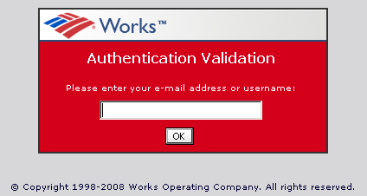

- Click Ok
- Enter a password in the Password field, and then enter the same in the password in the Confirm field. The Program Administrators will determine the password restriction and expiration.
- Click the arrow in the Question field and select the desired security validation question.
- Enter an answer to the question and repeat the same answer in the Confirm field and click Ok.
- Bookmark the following URL: Http://payment2.works.com

The home page displays
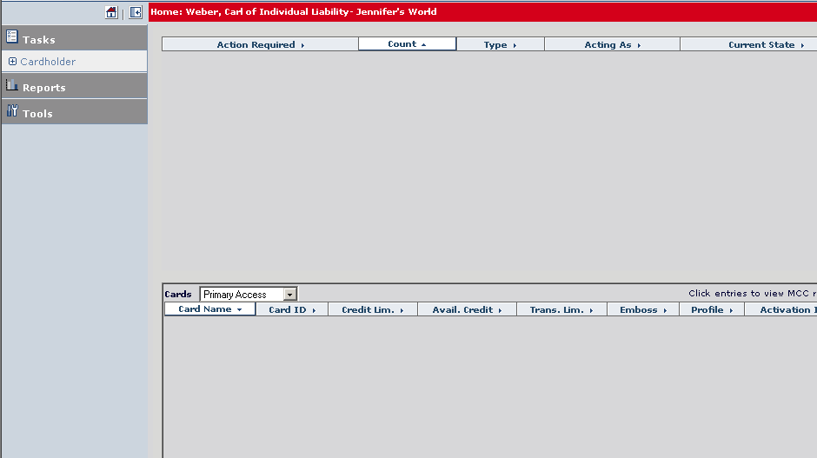
Completing Application and Agreeing to Terms & Condition

- Click Tools >Personal Setting > Travel Card in the left navigator bar
- The ‘Card Basics’ sections will default with the user’s name
- Do not change the secondary emboss line that is defaulted.
- Enter your Social Security Number (SSN) and Date of Birth; the activation number will default to SSN.
- Select the Travel Frequency – this is your monthly credit limit. This is your requested limit and may not be the limit established on the card after the personal soft credit check is performed. For a more detailed explanation of how this limit works, please refer to the Bank of America Employee Paid (Individual Liability) Travel Card Terms sheet.
Travel Frequency:
    - $ 1,000
    - $ 1,500
    - $ 2,500
    - $ 5,000
If you need a limit greater than $5,000 you must apply for $5,000 and notify your Program Administrator of the actual limit you need permanently on your card. A request through Bank of America will be made and if your personal credit will support the higher limit, it will be established on the card. If your personal credit does not support the higher limit, the limit will be established at the amount your credit will support.

Note: Once an individual liability card request has been created, the potential cardholder must review Term and Conditions. In the case of an application submitted by an Administrator, the cardholder will be notified of card requests requiring Terms & Conditions review via email according to his email frequency settings.
6. Click on ‘Save’ button to proceed to review and submit Terms and Conditions

Once the user click the ‘Save’ button the following screen displays:

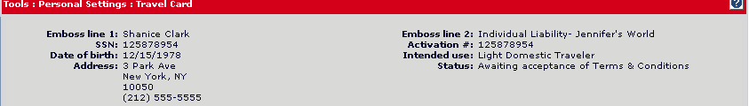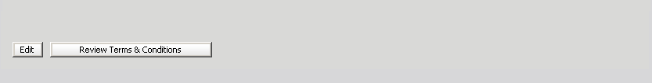

- The user will then click on the ‘Review Terms & Conditions’ button.

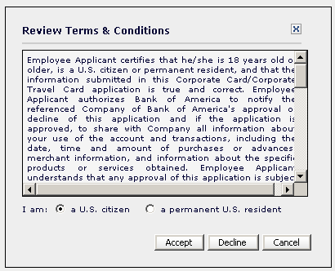

- The user must indicate if they are an U. S Citizen or a permanent U. S resident
- Click on the ‘Accept’ button to complete and agreed to the Terms & Conditions.

You will receive the card in 7 to 10 business days to the address indicated on the application form via US Mail.

Note: The credit limit will appear on your card carrier, if the card has the cash advance option, the pin will be sent separately.

If you have any questions, please contact your Travel Card Program Administrator whose contact information is listed on your Welcome Email.

